|  |  |
| --- | --- |
| **[Final Project] – External Document** |  |
| <Course Code>  <Human Computer Interaction> |
| [Even] Semester Year 2020/2021 |

* Project Title

HCI FINAL PROJECT

* Introduction

Creating a logo and designing a website for an online coffee shop that looks appealing, attractive and also easy to use.

* Report / Documentation

1. Creating the Logo

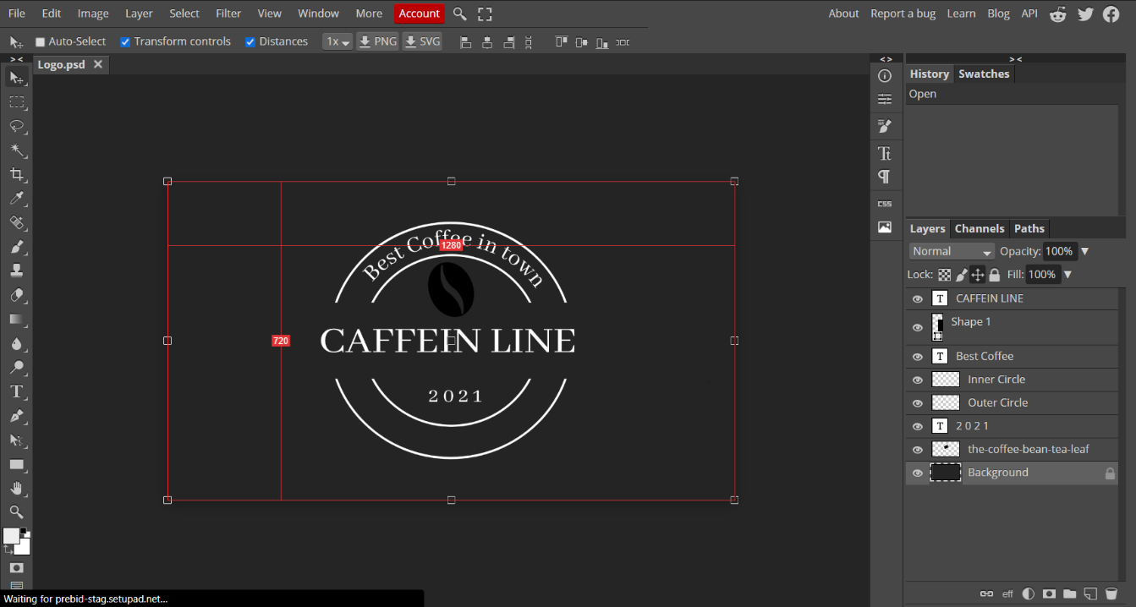

1. Blueprint of the homepage website

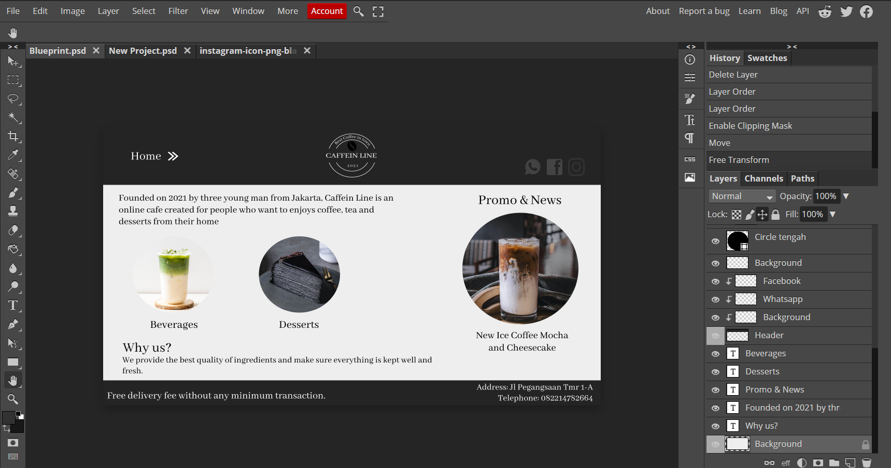

1. Designing the HTML for HomePage

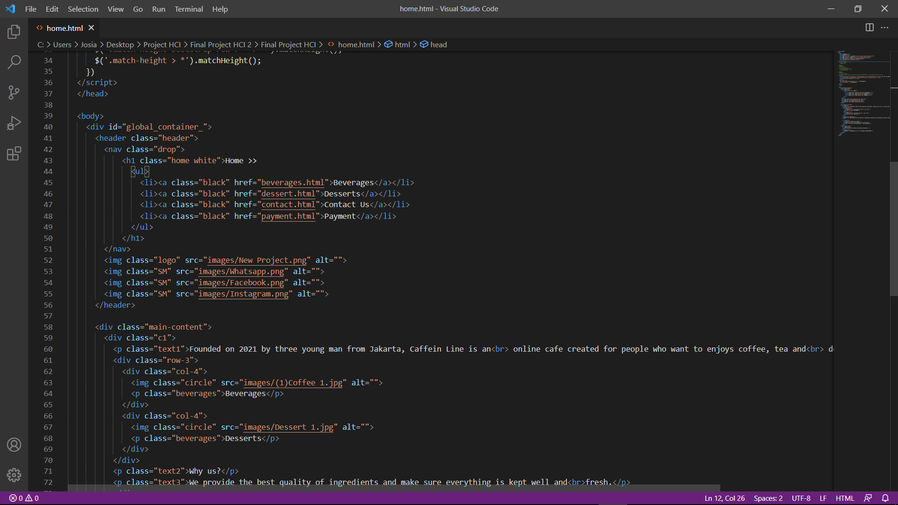

1. Designing the HTML for Dessert page  
   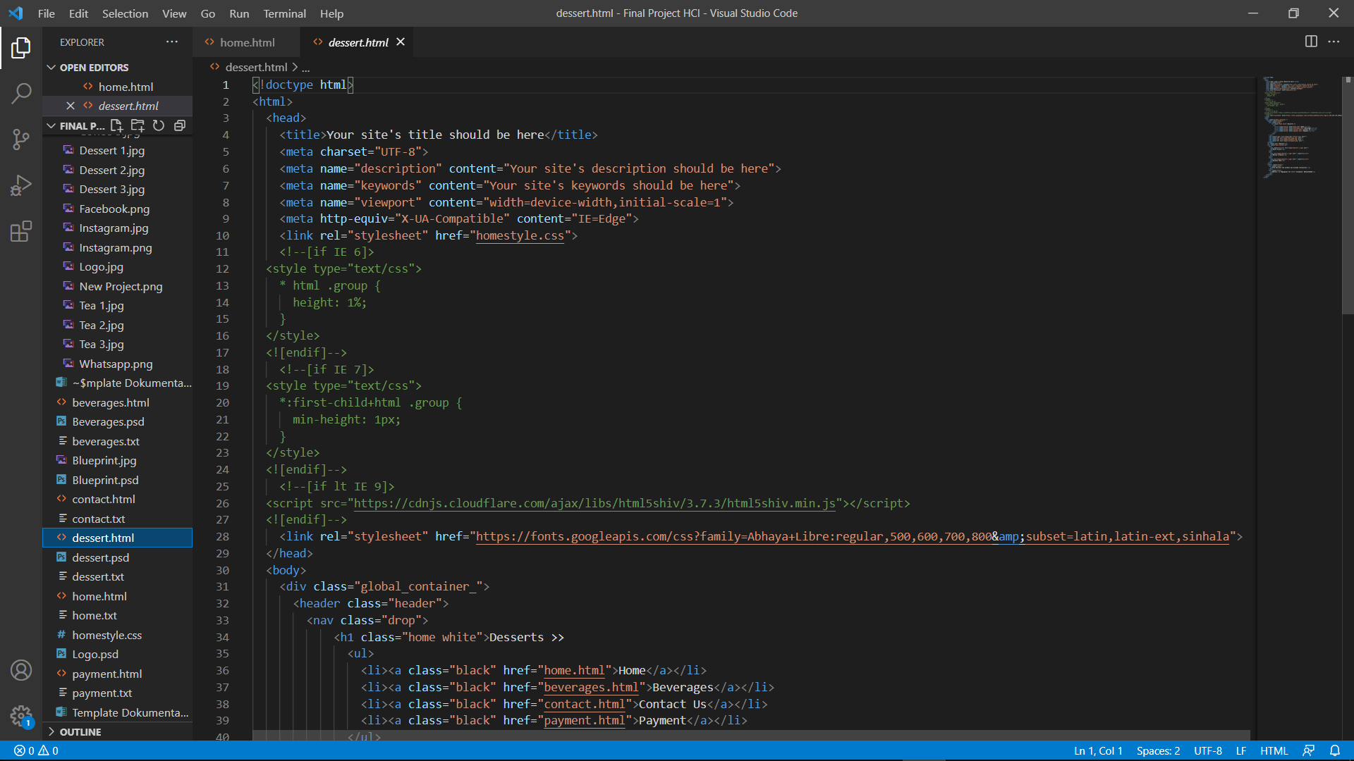
2. Designing the HTML for Contact Us page
3. Designing the HTML for page
4. Designing the website with CSS

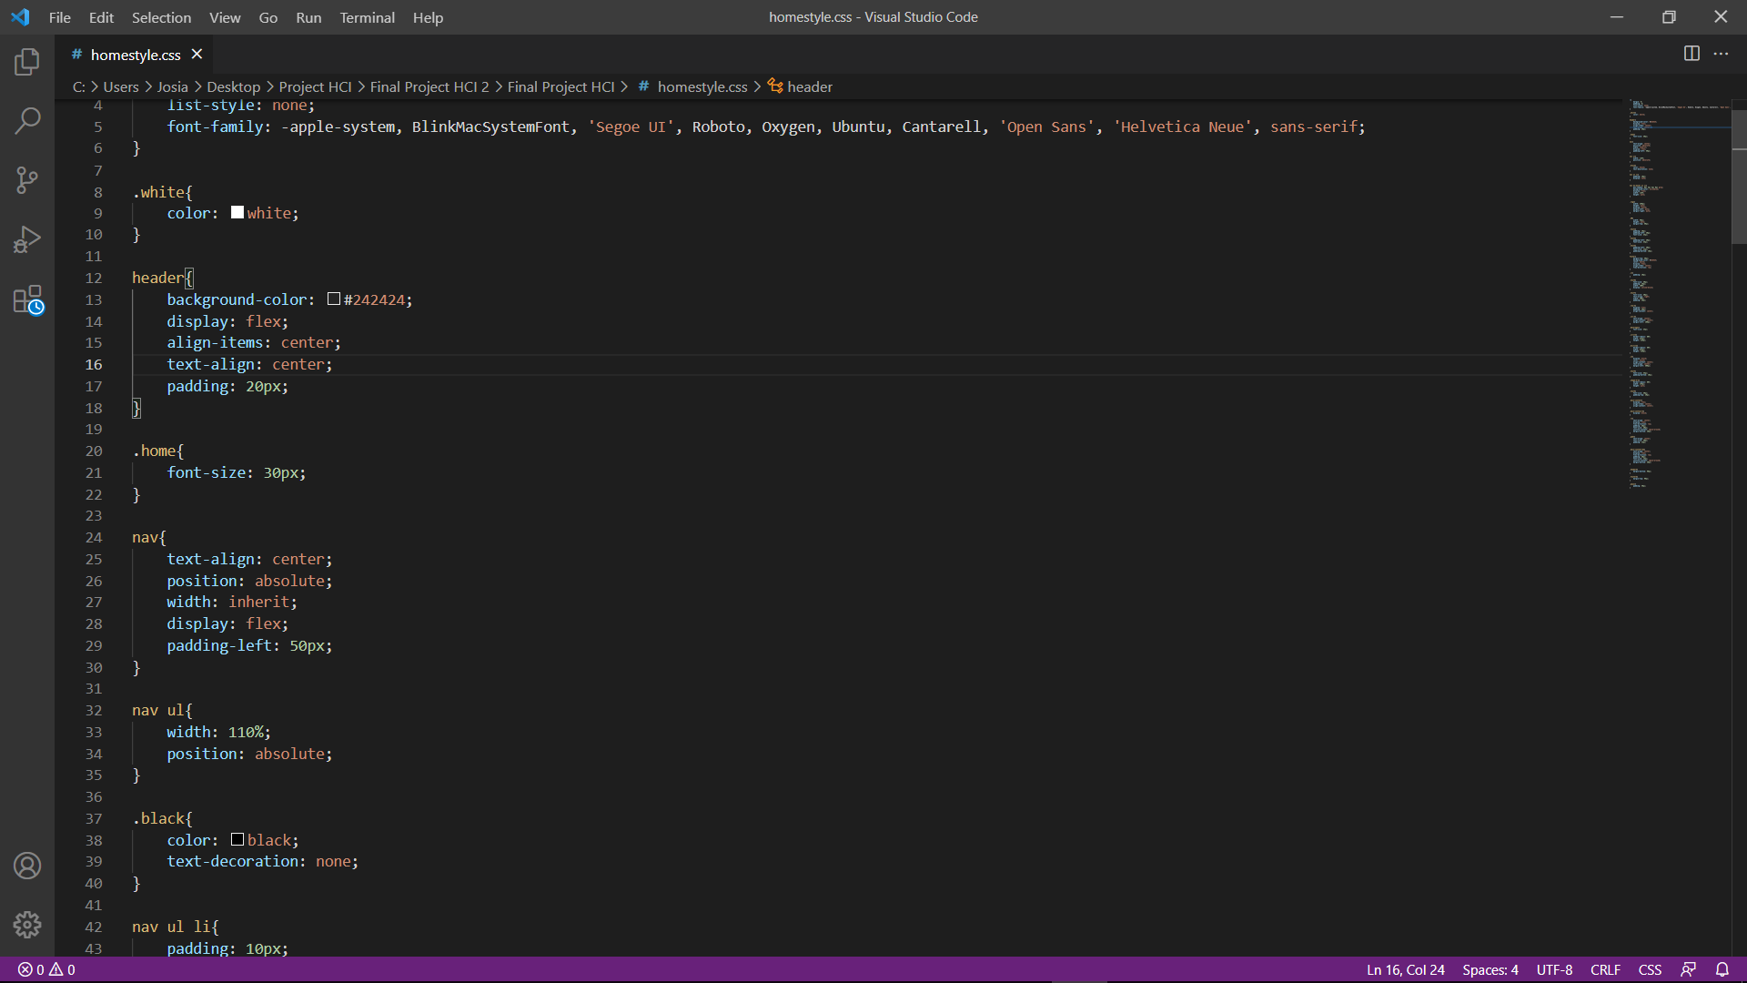

* Reference
* <https://id.pinterest.com/pin/466544842644118415/>
* <https://www.freepik.com/premium-photo/iced-hibiscus-tea-lemonade-with-raspberries-mint_6778177.htm>
* <https://www.freepik.com/premium-photo/iced-lychee-tea-with-straw-mint-leaves_8458532.htm>
* <https://magfood-amazy.com/product/ice-lemon-tea/>
* <https://eventkampus.com/blog/detail/957/manfaat-minum-3-4-cangkir-kopi-perhari-bagi-kesehatan>
* <https://teapasar.blog/2019/11/13/bon-appetea-matcha-mille-crepe-cake/>
* <https://www.123rf.com/photo_57170153_slice-of-rainbow-birthday-cake.html>
* <https://www.pngaaa.com/detail/1671515>
* <https://www.pinclipart.com/pindetail/ximmxb_whatsapp-logo-transparent-png-whatsapp-logo-vector-black/>
* Group Member
* 2440020695 – Kevin Tio
* 2440041232 – Josia Sean Audric Santoso
* 2440008140 – Virgilius Karel